1 Overview

1.1 Project Summary

**1.1.1 Purpose**

The Software Project Management Plan (SPMP) outlines the management of the Congenital Heart Disorder mobile application development for the beginning iterations of the project. It contains the organization, development cycle plans, the timeline, testing guidelines, and the maintenance plan for the application for the later groups. The plans will be inspected by our CEO, Dr. Concepcion, and our client, Vanessa Miller.

**1.1.2 Scope of the Project**

The scope of this plan is to explain the initial development for the Congenital Heart Disorder application. It will outline what will be done, who will do what and the methods that we have adopted. We have specified in the current SRS that we will be focused on completing:

* Application Development
* Quality Assurance
* Documentation

The first prototype of the project will have the framework for the initial screens of the application. And the second prototype will have a functional Home Page, Track Your Child, Hospital Helpline, and Contacts pages.

**1.1.3 Assumptions and Constraints**

We will follow these assumptions:

1. All members are following the approved versions of the SRS and SPMP
2. The client will respond to our inquiries.
3. Everyone will attend lab sessions to meet and discuss.
4. Everyone will dedicate time outside of lab to finish their development
5. All deadlines will be met with their tasks.
6. The application will work on the iOS devices.
7. Everyone will contribute and help each other to accomplish our goals.

**1.1.4 Schedule and Budget Summary**

No budget was given to us for this project. We are expected to deliver a functional Prototype 1 by the 7th week of class. And a final, Prototype 2, on the final day of class.

**1.1.5 Project Deliverables**

1. SRS, SPMP, SQAP, Software Architecture, Detailed Design, Test Plans, Documented Source Code, and Maintenance Manual.
2. Executable Application running on an iOS platform

1.2 Evolution of the Plan

The Project Manager, Alejandro Avila, met with our client, Vanessa Miller, on January 22, 2018. They discussed what they were wanting for the first development milestone of their application. During this meeting, they established the frame work, concepts, and requirements from us. To establish the base app, meet with our UI/UX team to design an app logo. While we all trained ourselves in the IDE being used for design, XCode.

2 References

* IOS developers

<https://developer.apple.com/library/content/referencelibrary/GettingStarted/DevelopiOSAppsSwift/>

* CSUSB OSMM Software Project Management Plan (SPMP) example.

3 Acronyms and Abbreviations

* IOS – Apple's mobile operating system
* XCode – Apple's IDE for the macOS and IOS applications
* IDE – Integrated Development Environment
* 3G – Third Generation of wireless data standard
* 4G – Fourth Generation of wireless data standard
* MySQL – Database language that interacts with a server to query data
* Swift – Apple's programming language for mobile applications
* HTTPS – Secure transfer protocol for server communication.
* WiFi – Wireless internet for devices
* SRS – Software requirement specifications
* CHD – Congenital Heart Disorder
* SPMP – Software Project Management Plan
* SQAP – Software Quality Assurance Plan

4 Project Organization

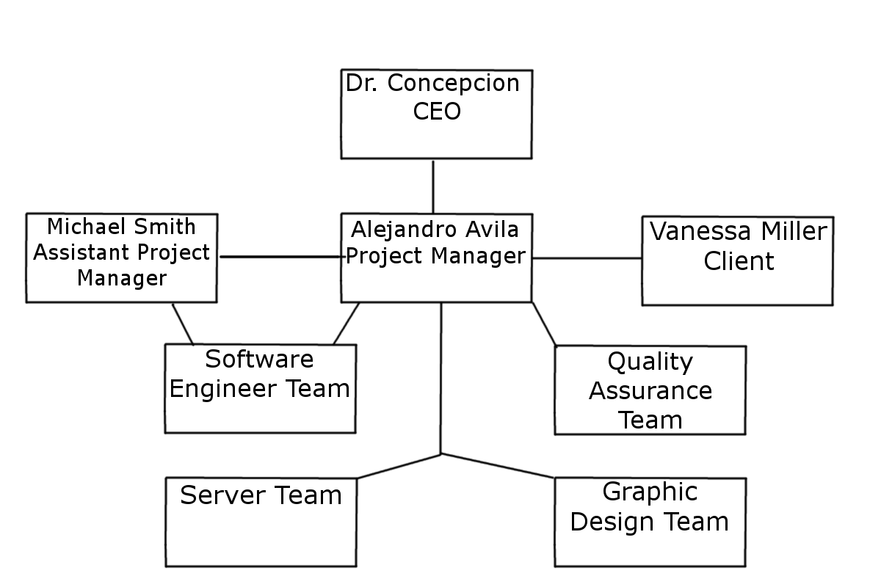

**4.1 External Interfaces**

**Dr. Concepcion (CEO) -** Monitors performance of all the development teams. Provides guidance to the Project Manager, analyzes and gives advice on documentation and heads the board meetings.

**Vanessa Miller (Client) -** Conveys her ideas about the app to the project managers. Provides any required documentation or information to the team. Gives feedback on the prototypes.

**Alejandro Avila (Project Manager) -** Connection between the team, CEO, and client. Communicates with the team on the client's ideas, verifies that we stay on track to meet deadlines, and that we are following the outlines stated in the documentation. Works with the design and server team to ensure the correct tools are provided to the software team.

**Michael Smith (Assistant Project Manager) -** Works alongside and monitors the software engineering team. Provides assistant to the project manager when needed and helps keep the team on track. Produces code for the app as well.

**Design Team -** Plans the layout and function of the app. Designs the app logo. Reports to the project manager.

**Software Engineering Team –** Codes the objects and screens for the app. Reports to the assistant project manager.

**Server Team –** Receives the requirement for the development team for the application presentations. Issues the communication ports, provides the server and databases need for the application. Maintains a stable connection to the host application.

**QA Team –** Tests the prototypes for any flaws and gives the results to the development team for debugging or gives approval. Follows the testing guidelines outlined in the SQAP.

**4.2 Internal Interfaces**

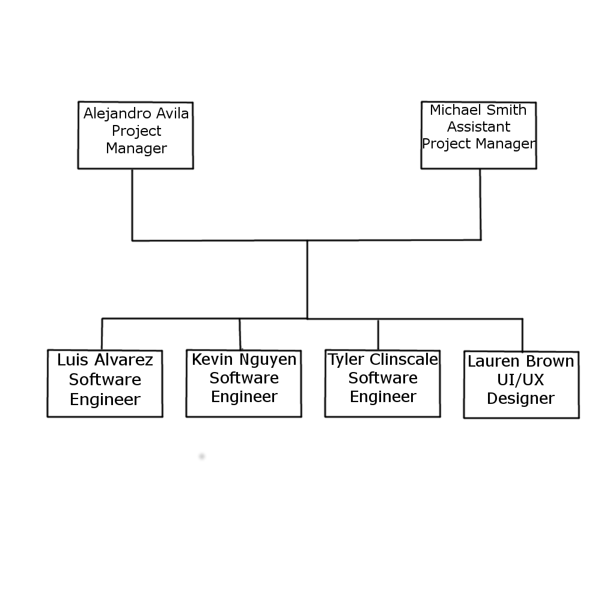

The Project Manager and the Assistant Project Manager will work together to observe development and provide assistance to the team to meet project deadlines.

**4.3 Roles and Responsibilities**

**Alejandro Avila (Project Manager) -** Connection between the team, CEO, and client. Communicates with the team on the client's ideas, verifies that we stay on track to meet deadlines, and that we are following the outlines stated in the documentation. Works with the design and server team to ensure the correct tools are provided to the software team.

**Michael Smith (Assistant Project Manager) -** Works alongside and monitors the software engineering team. Provides assistant to the project manager when needed and helps keep the team on track. Produces code for the app as well. Produces the Home Screen for the application

**Luis Alvarez –** Programmer assigned to implement the Contacts function of the application. Creating the subtrees required to display the information in an organized manner.

**Kevin Nguyen -** Programmer assigned to implement the Track Your Child function of the application. Creating the subtrees required to display the information in an organized manner. And to store the data entered by the user.

**Tyler Clinscales -** Programmer assigned to implement the Hospital Helpline function of the application. Creating the subtrees required to display the information in an organized manner.